**Central Logging Requirments**

1) FluentD used for listen logs from all application , FluentD running in Couchbase Prod mechine, Fluentd configured with applications which need to be logged.

2) configuration in fluent D

Install fluentD

goto to fluent directory

ubuntu@couchbase-prod:/etc/fluent$

goto configuration file change as shown below in example

ex:

<source>

type forward

port 24226

</source>

<filter *.**>

type elasticsearch_timestamp_check

</filter>

<match proposal.*>

type copy

<store>

type elasticsearch

host 52.25.159.93

port 9200

include_tag_key true

tag_key @log_name

flush_interval 10s

index_name proposal

type_name string

</store>

</match>

Note : index name should be lower case othrwise it will not create index in elastic search.

Start to fluentD

ubuntu@couchbase-prod:/etc/fluent$ fluentd -c start

2) In applications we need change logger file , and logger code

Ex: Given Repo link has configuration file , in configuration we mentioned what are logs to be listen ,

fluentd running mechine host and port need be added in configuration.

<https://github.com/guysyml/taskcreationapp/blob/master/CreatingToDoistTasks/conf/application-logger.xml>

In code we need declare log like this

Play Application:

private static org.slf4j.Logger log = play.Logger.underlying();

Maven Application:

static Logger log = LoggerFactory.getLogger(CouchBaseOperation.class);

and we need add these jars in pom if its maven application or if it is play application we need add jars in build. Sbt

|  |
| --- |
| "org.fluentd" % "fluent-logger" % "0.3.1", |
| "ch.qos.logback" % "logback-classic" % "1.0.7", |
| "com.sndyuk" % "logback-more-appenders" % "1.1.0", |

Log back is not availabal in maven so taking from repo

resolvers += "Logback more appenders" at "http://sndyuk.github.com/maven"

4) when First time when we run application which configured with fluentd , when data is logged , Index will created in elastic search , later same index used to store logs

5)In kibana we added all indexs application which are logging ,

Adding Index:

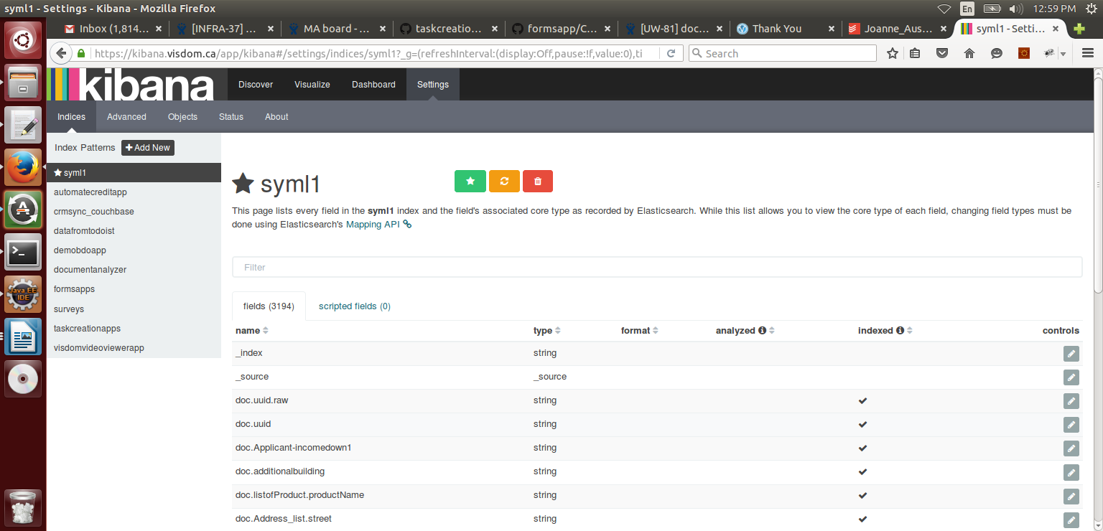

adding time stamp

